**TRIBHUVAN UNIVERSITY**

**INSTITUTE OF SCIENCE AND TECHNOLOGY**



Internship Project Report on

**WordPress Site Migration to AWS EC2 with CyberPanel and Nagios Monitoring**

at

**Genese Solution Pvt. ltd.**

For the partial fulfillment of the requirements of the degree of

**Bachelor of Science in Computer Science and Information Technology (B.Sc.CSIT)**

awarded by Tribhuvan University

**Submitted By:**

Sanjeev Basnet (20354/075)

TU Registration No.: 5-2-282-92-2018

**ST. XAVIER’S COLLEGE**

Maitighar, Kathmandu, Nepal

**Submitted To:**

Office of the Dean

Institute of Science and Technology

Tribhuvan University

Kathmandu

September 2023



**SUPERVISOR’S RECOMMENDATION**

This is to certify that the final year Internship Project entitled **“WordPress Site Migration to AWS EC2 with CyberPanel and Nagios Monitoring”** is an academic work completed by **Sanjeev Basnet (20354/075)** submitted in the partial fulfillment of the requirements for the degree of Bachelor of Science in Computer Science and Information Technology awarded by Institute of Science and Technology, Tribhuvan University under my guidance and supervision. The information presented by him in the report has not been submitted earlier to the best of my knowledge.

Signature of the Supervisor

Name: Ganesh Yogi

Designation: HOD, Department of Computer Science

Date: Sept, 2023



**CERTIFICATE OF APPROVAL**

The undersigned certify that they have read and recommended to the Department of Computer Science for acceptance, an Internship Project Proposal entitled “**WordPress Site Migration to AWS EC2 with CyberPanel and Nagios Monitoring**” submitted by **Sanjeev Basnet (20354/075)** for the partial fulfillment of the requirement for the degree of Bachelor of Science in Computer Science and Information Technology awarded by Tribhuvan University.

……………………………..

**Mr. Ankur Roy**

Company Supervisor

Senior Software Engineer

Genese Solutions Pvt. Ltd.

……………………………..

**Mr. Ganesh Yogi**

College Supervisor

St. Xavier’s College

……………………………..

**Mr. Ganesh Yogi**

HoD, Department of Computer Science

St. Xavier’s College

……………………………..

External Examiner

Faculty, CDCSIT, TU

# ACKNOWLEDGEMENT

I would like to express my sincere thanks to the Department of Computer Science and Information Technology, St. Xavier’s College, Maitighar, Kathmandu for providing me with this opportunity to explore my thoughts, curiosity and interest in the field of computer science through a thorough Final Year Internship Project on **" WordPress Site Migration to AWS EC2 with CyberPanel and Nagios Monitoring "**.

I am glad to take this opportunity to express my sincere gratitude and sincere thanks to our highly respected and esteemed guide **Mr. Ganesh Yogi**, Supervisor, St. Xavier’s College, for his valuable guidance, suggestion, encouragement, critical comment and help for completing this work. His constant support and motivation always encouraged me. My thanks to him will always be counted.

My sincere gratitude goes to **Er. Rajan Karmacharya, CTO**/Lecturer, Department of Computer Science, St. Xavier’s College, Maitighar for his wholehearted support. His useful suggestions for this whole work and cooperative behavior are sincerely acknowledged.

I would like to express my deepest sense of gratitude to my highly respected and esteemed mentor **Mr. Ankur Roy**, Sr. Associate Software Engineer, Genese solution for providing me an opportunity for completing my internship at their reputed organization. I would also like to thank the Genese Solution family for providing a wonderful and friendly environment to work in. Their useful suggestions for this whole work and cooperative behavior are sincerely acknowledged.

I am also grateful to all our teachers, for their constant support and guidance. At the end I would like to express my sincere thanks to all my friends and others who helped me directly or indirectly during the duration of the completion of this project.

**Sanjeev Basnet (TU Roll No. 20354/075)**

# ABSTRACT

This internship project presents a comprehensive exploration of the lifecycle of an online food ordering website, from its inception in a local development environment to its migration and optimization within the Amazon Web Services (AWS) cloud ecosystem. The project's primary aim was to elevate the website's overall performance, security, scalability, and availability, thus positioning it as a robust and efficient platform for online food ordering. The journey commenced with the creation of a fully functional website within a local XAMPP environment, showcasing the project's commitment to foundational development. It then embarked on an intricate migration process to AWS, managed by the CyberPanel, which streamlined server management. This transition to the cloud not only expanded the website's accessibility but also unlocked the potential for dynamic scaling in response to user demands. Optimization was a pivotal phase of the project, with a focus on image compression, caching mechanisms, and database tuning. Also, robust monitoring was integrated using AWS EC2 and Nagios, ensuring real-time insights into the website's performance and health. In conclusion, this internship project is based on the transformation of a locally hosted website into a scalable, high-performance online food ordering platform.

***Keywords:*** *AWS Migration, Optimization Techniques CyberPanel, XAMPP Development Environment, Performance Enhancement, Scalability, Nagios*

**TABLE OF CONTENTS**

ACKNOWLEDGEMENT i

ABSTRACT ii

LIST OF ABBREVIATIONS v

LIST OF TABLES vi

LIST OF FIGURES vii

CHAPTER 1: INTRODUCTION 1

1.1. Introduction 1

1.2. Problem Statement 1

1.3. Objectives 2

1.3.1. Internship Objectives 2

1.3.2. Internship Project Objectives 2

1.4. Scope and Limitation 2

1.5. Report Organization 2

CHAPTER 2: ORGANIZATION DETAILS AND LITERATURE REVIEW 4

2.1. Introduction to organization 4

2.2. Organizational Hierarchy 5

2.3. Working Domains of the organization 5

2.3.1. Cloud consultation and services 6

2.3.2. DevOps 6

2.3.3. Development 6

2.3.4. Email service 6

2.4. Description of Intern Line 6

2.5. Literature Review 7

CHAPTER 3: INTERNSHIP ACTIVITIES 9

3.1. Roles and Responsibilities 9

3.2. Weekly Log 9

3.3. Description of the Projects Involved During Internship 15

3.4. Tasks/Activities Performed 15

3.4.1. Website Development (Local Host - XAMPP): 16

3.4.2. AWS Migration: 16

3.4.3. CyberPanel Management: 18

3.4.4. Nagios Monitoring: 21

3.4.5. Testing and Quality Assurance: 22

3.4.6. Finalization and Evaluation: 23

CHAPTER 4: CONCLUSION AND LEARNING OUTCOMES 24

4.1. Conclusion 24

4.2. Learning Outcomes 24

4.2.1. Professional Level 24

4.2.2. Technical Level 24

REFERENCES 26

APPENDICES 27

# LIST OF ABBREVIATIONS

AWS Amazon Web Services

RDS Amazon Relational Database Service

VPC Virtual Private Cloud

IAM Identity and Access Management

EC2 Elastic Compute Cloud

URL Uniform Resource Locator

CPU Central Processing Unit

RAM Random Access Memory

ICT Information and Communication Technology

GCP Google Cloud Platform

IaaS Infrastructure as a Service

PaaS Platform as a Service

SaaS Software as a Service

G-Suite Google Suite

CMS Content Management System

AMI Amazon Machine Image

DNS Domain Name System

CLI Command Line Interface

IP Internet Protocol

HTTP Hypertext Transfer Protocol

HTTPS Hypertext Transfer Protocol Secure

ACL Access Control List

# LIST OF TABLES

**Table 1:** Organizational Details Chart 4

**Table 2:** Weekly Log of Activities 9

# LIST OF FIGURES

Figure 1: Organizational Hierarchy of Genese Solution 5

Figure 2: Wordpress site hosted on XAMPP Server 16

Figure 3: Selection of AMI 17

Figure 4: Key pair 17

Figure 5: Configuring network 18

Figure 6: Configuring security groups 18

Figure 7: Connected to SSH client through AWS CLI 19

Figure 8: Logging in to Cyberpanel through instance IP 19

Figure 9: Cyberpanel Configuration 20

Figure 10: Installing wordpress on Cyberpanel 20

Figure 11: Nagios Installation 21

Figure 12: Monitoring current status of the website through Nagios 21

Figure 13: Monitoring EC2 instance 22

Figure 14: Website migrated on AWS and logged in using Domain name and Ip address 22

Figure 15: Billing details 23

# CHAPTER 1: INTRODUCTION

## 1.1. Introduction

An internship is a professional learning experience that offers meaningful, practical work related to a student’s field of study or career interest. An internship gives a student the opportunity for career exploration and development, and to learn new skills. It offers the employer the opportunity to bring new ideas and energy into the workplace, develop talent and potentially build a pipeline for future full-time employees. (*What Is an Internship? – Career Center - UMBC*, n.d.)

The internship project revolved around migrating a WordPress website to an AWS EC2 instance and simultaneously deploying various AWS services, including RDS, VPC networking, IAM, and comprehensive infrastructure automation. Additionally, the author incorporated CyberPanel for efficient website management and integrated Nagios monitoring to ensure continuous performance monitoring. The principal objective of this project was to facilitate a smooth transition of the website to AWS, enhance its performance, and uphold vigilant monitoring practices to ensure operational excellence.

So as a Cloud intern responsibility are as follows:

* Assisting in the design, deployment, and management of cloud-based infrastructure
* Supporting the migration of on-premises systems or applications to the cloud
* Monitoring and optimizing cloud resources and implementing cloud security measures
* Working with different teams to integrate cloud services into their workflows, ensuring seamless communication and efficient utilization of cloud resources.
* Infrastructures automation and monitoring.

## 1.2. Problem Statement

The lack of practical experience and exposure to the specific organizational culture in cloud computing poses a challenge for students with foundational knowledge. Bridging the gap between academic understanding and industry expertise is crucial. A cloud internship provides an opportunity to gain hands-on experience, apply theoretical knowledge in a practical setting, and understand the unique culture of cloud-centric organizations.

## 1.3. Objectives

## 1.3.1. Internship Objectives

The internship program is being carried out to fulfill the academic requirements of Tribhuvan University's Bsc.CSIT 8th Semester. The following are some of the Internship program's goals:

* To gain a better understanding of organizational culture and accountability.
* To learn how to work in a group and develop teamwork abilities.
* To investigate and develop work experiences involving web application technologies.

### 1.3.2. Internship Project Objectives

* Migrating WordPress website to AWS EC2 for enhanced performance.
* Incorporate Amazon RDS for robust database management and establish secure VPC networking and IAM for access control.
* Automate infrastructure provisioning and management.
* Utilize CyberPanel for streamlined website administration.
* Implement Nagios for continuous performance oversight and Optimize website performance on AWS.
* Enhance security measures for data protection.

## 1.4. Scope and Limitation

The scope of the project involves migration and optimization of a local food ordering WordPress Site to AWS EC2 with CyberPanel management and Nagios monitoring as a cloud intern. This includes designing and developing an engaging user interface, implementing content management capabilities, utilizing cloud hosting for scalability and reliability, optimizing website performance, and implementing security measures.

The limitations of this project include time constraints, which may impact the depth of website development. Resource limitations, such as restricted access to budget and specialized tools, may affect the scale of implementation. Limited experience and expertise in certain areas could pose challenges in handling complex technical issues.

## 1.5. Report Organization

**Chapter 1-**Includes general introduction to the internship project. This gives the summary of the project and its purpose & the scope of this project.

**Chapter 2-**Captures the literature review of the existing system, its working & its advantages and disadvantages as well as introduction of the organization where the internship is being performed.

**Chapter 3-**Covers the Internship activities where the roles and responsibilities are thoroughly explained. Along with this weekly log with proper description of the project during the internship is mentioned.

**Chapter 4-**Includes the conclusion & learning outcome of the project.

**Appendix-**Describes the canvases of the system.

**References**-Includes the references which we have referred for working on this project.

# CHAPTER 2: ORGANIZATION DETAILS AND LITERATURE REVIEW

## 2.1. Introduction to organization

Genese Solution is a digital technology service company headquartered in the United Kingdom with a presence in 8 different geographies including Nepal. Genese solution helps companies adapt more efficiently by transforming their operational models and technological platforms (*Genese Solution Limited*, n.d.).

The objective of Genese solution is “To design, deliver, and innovate: to create a transformational ecosystem in the ICT sector, across different global locations. Enabling companies and startups across the nation to efficiently and cost-effectively utilize their ICT capabilities to deliver their own products and services better.” The organization offers various services to its clients including Website Development, Software Development, Mobile Application Development, Domain and Web Hosting, SEO, Email Services, Cloud Consultation & Services, Business Monitoring Tools, Project Management Tools (*Genese Solution Limited*, n.d.).

The organization has over 200 employees working in-house in the office as well as remotely with over 200+ customers worldwide including IMS Software, Pathao, Sastodeal, Buddha Air in Nepal (*Genese Solution Limited*, n.d.).

**Table 1**

Organizational Details Chart

|  |  |
| --- | --- |
| Topic | Details |
| Name | Genese Solution |
| Establishment | 2013 AD |
| Location | Bakhundole, Lalitpur, Nepal |
| Phone Number: | 9801268810 |
| Email: | info@genesesolution.com |

## 2.2. Organizational Hierarchy

Having a well-defined hierarchy within an organization is crucial for its effective operation. Genese Solution, like any other organization, has established a functional organizational structure in order to accomplish its objectives, mission, and goals. At the helm of this structure is the Global Chief Technology Officer (CTO) who serves as the head of the organization. Genese Solution comprises various departments including Administration, Human Resources (HR), Development Team, Cloud Team, Marketing Team, and Customer Success Team. Additionally, the company has a Chief Executive Officer (CEO) based in Nepal who oversees the overall functioning of the organization.

**Figure 1**

Organizational Hierarchy of Genese Solution

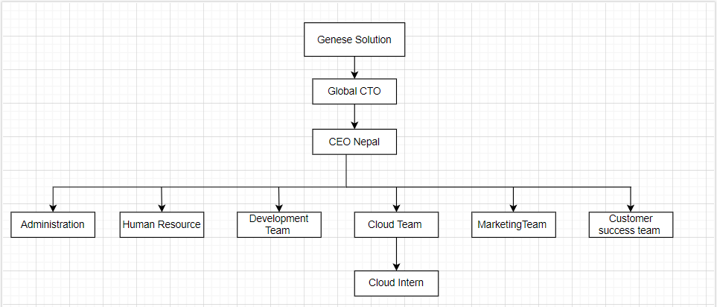

## 2.3. Working Domains of the organization

The working domains of organization are as follow:

### 2.3.1. Cloud consultation and services

Genese offers multi-platform Cloud Services & Consultation of the biggest and best names in the world industry namely Amazon Web Services, Azure, Google Cloud Platform and Digital Ocean (*Genese Solution Limited*, n.d.).

### 2.3.2. DevOps

DevOps is the combination of cultural philosophies, practices, and tools that increases an organization’s ability to deliver applications and services at high velocity: evolving and improving products at a faster pace than organizations using traditional software development and infrastructure management processes. Genese offers various devops approaches like resource management, automation, agile development and continuous improvement (*Genese Solution Limited*, n.d.).

### 2.3.3. Development

A team of seasoned professionals ensures the delivery of reliable and scalable software solutions for any Operating System, browser and device bringing together technical prowess and deep industry expertise coupled with the latest IT advancements- to deliver products that aptly fit the clients’ requirements (*Genese Solution Limited*, n.d.).

### 2.3.4. Email service

Offers email services & collaboration technologies of market leaders like G-Suite, Office365 and Zoho Mail according to your specific business and security requirements and help you bolster business productivity (*Genese Solution Limited*, n.d.).

## 2.4. Description of Intern Line

Genese solutions employs interns through a rigorous interview process designed to assess their expertise in cloud-related matters and provide them with a valuable opportunity to gain practical experience within a hands-on cloud environment. Interns receive diligent supervision on the practical utilization of a multitude of real-life tools through the utilization of cloud resources and virtual machines. This exceptional opportunity empowers undergraduate students to engage in rigorous study, foster skill development, and enhance their technical capabilities.

During the internship period, interns operate within a dedicated line structure, which includes a line coordinator, line manager, and Project head. They receive supervision from project leads assigned to their specific projects. Interns are given daily project tasks by their supervisors, and at the end of each day, they submit their worklog to both their supervisors and the intern line. Performance evaluation is based on their overall performance, and if deemed satisfactory, interns may be offered a position as an Associate Cloud Engineer in the organization. This involves undergoing technical and HR interviews as part of the hiring process.

## 2.5. Literature Review

Cloud computing has transformed the way organizations manage computing resources (*Armbrust et al*., 2010). It offers on-demand access to a wide array of computing services via the internet, including storage, processing power, and networking. The cloud's scalability, cost-effectiveness, and flexibility have made it a cornerstone of modern business operations. Cloud computing has various deployment models, including public, private, and hybrid clouds. These models enable organizations to tailor their cloud infrastructure to their specific needs. Additionally, cloud service models such as Infrastructure as a Service (IaaS), Platform as a Service (PaaS), and Software as a Service (SaaS) provide a range of solutions for various business requirements (*Hassan*, 2018).

Amazon Web Services (AWS) is a frontrunner in the cloud services sector, offering an extensive suite of cloud computing solutions *(Amazon Web Services*, 2021). AWS provides Infrastructure as a Service (IaaS) for foundational resources like virtual machines, Platform as a Service (PaaS) for building and deploying applications, and Software as a Service (SaaS) for ready-to-use software applications. AWS has a global presence, with data centers in various regions, ensuring low-latency access for users worldwide. AWS's comprehensive set of services covers computing, storage, databases, machine learning, analytics, and more. Its pay-as-you-go pricing model allows businesses to scale resources as needed, reducing costs and increasing flexibility (*Mell & Grance*, 2011).

Security is of paramount importance in cloud computing, and AWS offers robust security services (*Amazon Web Services*, 2021). AWS Identity and Access Management (IAM) is a fundamental service that enables organizations to manage and control access to AWS resources securely. With IAM, organizations can define user roles, permissions, and policies, ensuring data integrity and guarding against unauthorized access (*Balachandar*, 2017). In addition to IAM, AWS provides numerous security services and features, including encryption, firewalls, and monitoring tools. AWS's shared responsibility model outlines the division of security responsibilities between AWS and its customers, ensuring a secure cloud environment.

AWS empowers organizations with tools and services to automate infrastructure management and achieve scalability. AWS Auto Scaling is a key feature that automatically adjusts resource capacity based on workload demand, ensuring optimal resource utilization (*Amazon Web Services*, 2021). This enables businesses to handle varying levels of traffic and maintain high availability.

Infrastructure automation is facilitated by AWS CloudFormation, which allows organizations to provision and manage cloud resources using templates (*Brock et al.,* 2017). This simplifies resource provisioning, reduces manual tasks, and enhances efficiency. AWS's emphasis on scalability and automation aligns with modern cloud-native principles, allowing organizations to adapt quickly to changing demands and optimize resource usage.

Google Cloud Platform (GCP) is a prominent cloud service provider known for its diverse range of cloud computing solutions. GCP offers Infrastructure as a Service (IaaS), Platform as a Service (PaaS), and Software as a Service (SaaS) options, mirroring the service models offered by AWS (*Google Cloud*, 2021).

Microsoft Azure stands out as a leading cloud platform developed and operated by Microsoft. It serves businesses on a global scale by providing a comprehensive suite of cloud services. These services encompass virtual machines, databases, artificial intelligence (AI) and machine learning tools, and Internet of Things (IoT) solutions, making it a versatile cloud platform for various business needs (*Microsoft Azure*, 2021).

In the cloud computing industry, AWS, GCP, and Azure, often referred to as the "big three," offer a wide spectrum of services and solutions for organizations to manage their cloud resources efficiently. These cloud providers are frequently compared based on factors such as pricing, global reach, and the specific service offerings they provide. This competition empowers businesses to select the cloud provider that aligns most closely with their unique requirements (*Mell & Grance*, 2011).

# CHAPTER 3: INTERNSHIP ACTIVITIES

## 3.1. Roles and Responsibilities

During their tenure as a "Cloud Intern" at Genese Solutions Pvt. Ltd., their primary responsibility revolved around acquiring knowledge and developing a comprehensive understanding of various cloud computing aspects. This encompassed gaining proficiency in cloud infrastructure, networking, and services across platforms such as AWS, Azure, and Google Cloud. Their tasks also included:

Deployment and Management of Cloud Resources: Configuring and managing cloud infrastructure components.

* Security and Access Control: Implementing security measures and access management in the cloud.
* Cost Optimization: Reducing cloud costs through resource optimization.
* Automation: Developing scripts for automated cloud resource provisioning.
* Monitoring and Alerting: Setting up cloud resource monitoring systems.
* Cloud Service Integration: Integrating cloud services into existing workflows.
* Documentation: Creating documentation for cloud architectures and procedures.

## 3.2. Weekly Log

The 12-week long internship at Genese Solutions has been logged in this section. Also, the signed and stamped log reports are included in the appendix section of the report.

**Table 2**

Weekly Log of Activities

|  |  |
| --- | --- |
| Weeks | **Activities** |
| Week 1 | **Responsibilities:**   * Build a foundational understanding of cloud computing services.   **Activities Performed:**   * Enrolled in AWS courses covering Cloud Computing Fundamentals and AWS Architecting. * Gained hands-on experience with AWS services, including storage, static website hosting, EC2 instances, and RDS databases. * Studied and implemented security measures for users and applications. * Explored the concepts of elasticity, high availability, and monitoring in AWS.   **Observations:**   * Acquired a strong foundation in cloud computing concepts and AWS services. * The hands-on labs provided practical experience and enhanced understanding. * Realized the importance of security, scalability, and monitoring in cloud environments. |
| Week 2 | **Responsibilities:**   * Deepen understanding of cloud architecture and automation.   **Activities Performed:**   * Studied and completed labs on automating architecture in AWS. * Explored dynamic content delivery using Amazon CloudFront. * Learned about building decoupled architectures in the cloud. * Focused on disaster recovery planning and completed relevant labs.   **Observations:**   * Advanced knowledge in cloud architecture and automation. * Understanding of content delivery, decoupling, and disaster recovery in AWS. * Realized the significance of designing resilient and scalable cloud architectures. |
| Week 3 | **Responsibilities:**   * To understand about cloud security, access control, and application security.   **Activities Performed:**   * Configured IAM roles and policies on AWS to manage access. * Implemented multi-factor authentication (MFA) to enhance security. * Focused on designing secure applications and architecture. * Explored the selection of appropriate data security models. * Studied and practiced designing cost-optimized cloud architectures.   **Observations:**   * Realized the critical role of robust security measures in cloud environments. * Gained insights into secure application design and data security models. * Understood the importance of cost optimization in cloud architecture. |
| Week 4 | **Responsibilities:**   * To explore Google Cloud Platform (GCP) and its services. * To complete and explore knowb4 training.   **Activities Performed:**   * Gained hands-on lab experience with various Google Cloud services. * Completed the "Knowb4" assignment focused on preventing phishing attacks. * Enrolled in skill builder courses related to Google Cloud.   **Observations:**   * Acquired practical experience with GCP services, enhancing cloud expertise. * Learned about security measures to combat phishing attacks. * Demonstrated a commitment to continuous learning by enrolling in skill builder courses. |
| Week 5 | **Responsibilities:**   * To enroll in the AWS Cloud Essential learning path.   **Activities Performed:**   * Completed hands-on labs on Amazon S3 and Amazon RDS. * Undertook a project involving the dynamic migration of a cafe business website to AWS. * Accomplished the transformation of cafe server data in Amazon RDS.   **Observations:**   * Advanced learning through the AWS Cloud Essential learning path. * Gained practical experience with Amazon S3 and Amazon RDS. * Successfully completed a real-world project involving website migration and data transformation in AWS. |
| Week 6 | **Responsibilities:**   * Create a Virtual Private Cloud (VPC) environment for the cafe website.   **Activities Performed:**   * Successfully set up the VPC environment for the cafe website. * Initiated preparations for Solutions Architect courses. * Delved into Identity and Access Management (IAM) concepts. * Completed hands-on labs on IAM for granting access. * Studied routing policies, including DNS and IP configurations.   **Observations:**   * Accomplished the creation of a secure VPC environment. * Began in-depth exploration of IAM and its practical applications. * Gained insights into routing policies, enhancing networking knowledge. |
| Week 7 | **Responsibilities:**   * Study Amazon S3 bucket policy and advanced features.   **Activities Performed:**   * Successfully understood and explored Amazon S3 bucket policies. * Focused on studying S3 versioning and its significance. * Explored S3 replication capabilities. * Completed courses and hands-on labs on advanced Amazon S3 features.   **Observations:**   * Gained a comprehensive understanding of Amazon S3 bucket policies. * Acquired knowledge of S3 versioning, replication, and advanced functionalities. * Further advanced skills through in-depth courses and labs on advanced Amazon S3 features. |
| Week 8 | **Responsibilities:**   * Study networking concepts in AWS.   **Activities Performed:**   * Explored Amazon Virtual Private Cloud (VPC) features, benefits, and use cases. * Learned how to configure public and private subnets within a VPC. * Discussed the configuration of route tables to direct traffic in the network. * Studied the use of an internet gateway and a virtual private gateway for traffic management. * Explored the configuration of security in a VPC using network access control lists (network ACLs) and security groups.   **Observations:**   * Developed a strong understanding of AWS networking concepts and VPC configuration. * Recognized the importance of effective security measures in a VPC. * Gained insights into IP addressing and resource management within a VPC. |
| Week 9 | **Responsibilities:**   * To focus on advanced cloud concepts, specifically microservices and Serverless architectures.   **Activities Performed:**   * Delved into event-driven architectures and their significance. * Explored the features and benefits of AWS Lambda functions, a core component of Serverless computing. * Discussed the configuration of AWS Lambda functions. * Identified methods for monitoring AWS Lambda functions. * Described best practices for working with AWS Lambda and Serverless architecture.   **Observations:**   * Gained in-depth knowledge of microservices, Serverless concepts, and event-driven architectures. * Developed practical skills in configuring, monitoring, and working with AWS Lambda functions. * Demonstrated the ability to design a Serverless architecture for real-world projects. * Acquired an understanding of the broader AWS Serverless ecosystem. |
| Week 10 | **Responsibilities**   * Focus on container technologies in AWS, including Docker, Amazon ECS, AWS Fargate, and Amazon EKS.   **Activities Performed:**   * Studied containerization concepts, with a particular focus on Docker. * Explored Amazon ECS (Elastic Container Service) and its capabilities for container orchestration. * Learned about AWS Fargate, a serverless compute engine for containers. * Delved into Amazon EKS (Elastic Kubernetes Service) for managing Kubernetes clusters. * Designed and implemented a containerized application deployment on Amazon ECS   **Observation:**   * Gained a comprehensive understanding of container technologies in AWS. * Acquired hands-on experience with Docker, ECS, Fargate, and EKS. * Successfully completed a container deployment project, demonstrating practical skills in containerization and orchestration on AWS. |
| Week 11 | **Responsibilities:**   * Focus on the automation of the cafe website and delve into data and analytics in AWS.   **Activities Performed:**   * Worked on a project to fully automate the cafe website, optimizing its functionality and operations. * Explored data and analytics services in AWS, including data storage, processing, and visualization.   **Observations:**   * Successfully completed a project to fully automate the cafe website, improving efficiency and user experience. * Gained familiarity with AWS data and analytics services, setting the foundation for future data-driven projects and insights. |
| Week 12 | **Responsibilities:**   * Explore various DevOps tools, including Terraform and Nagios.   **Activities Performed:**   * Studied and gained proficiency in DevOps tools such as Terraform for infrastructure automation and Nagios for monitoring. * Completed a client project involving the migration of a WordPress site to AWS EC2. * Automated the site deployment and management using Terraform. * Implemented Nagios for continuous monitoring and performance oversight of the WordPress site.   **Observation:**   * Gained proficiency in DevOps tools like Terraform and Nagios, enhancing automation and monitoring capabilities. * Successfully completed a real-world client project, showcasing expertise in WordPress site migration, automation, and monitoring on AWS EC2. |

## 3.3. Description of the Projects Involved During Internship

This internship project revolved around the complete lifecycle of an online food ordering website. Starting with the development of a functional website on a local environment (XAMPP), the project encompassed the meticulous migration of this local setup to Amazon Web Services (AWS) using CyberPanel for efficient server management. Additionally, the project involved fine-tuning the website's performance through optimization techniques and implementing robust monitoring with AWS EC2 and Nagios. The primary objective was to enhance the website's overall performance, security, scalability, and availability while transitioning it to the AWS cloud environment

## 3.4. Tasks/Activities Performed

This section includes the list of activities performed during the internship period while being involved in the above-mentioned projects:

### 3.4.1. Website Development (Local Host - XAMPP):

Created a local development environment using XAMPP, including web server and database components. Developed a fully functional online food ordering website using WordPress as the content management system (CMS). Designed and customized the website layout, user interface, and navigation for an optimal user experience.

**Figure 2**

Wordpress site hosted on XAMPP Server

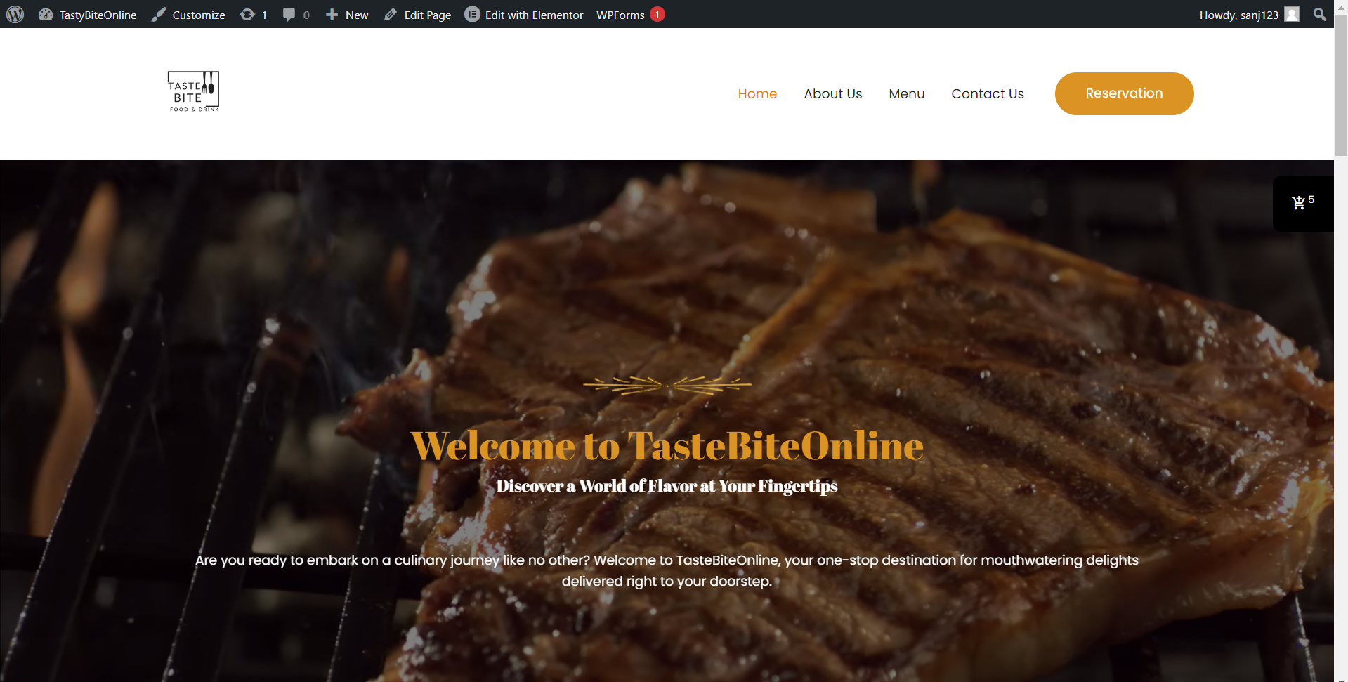

### 3.4.2. AWS Migration:

Provisioned an AWS EC2 instance with appropriate specifications and resources to host the website in the cloud environment. “As part of the AWS migration phase, an AWS EC2 instance was provisioned with appropriate specifications and resources to host the website in the cloud environment. An Ubuntu Amazon Machine Image (AMI) was selected, and a key pair was created for the EC2 instance. Additionally, network settings were configured to allow SSH and HTTPS traffic from the internet, and security groups were configured to allow inbound traffic to various ports.

**Figure 3**

Selection of AMI

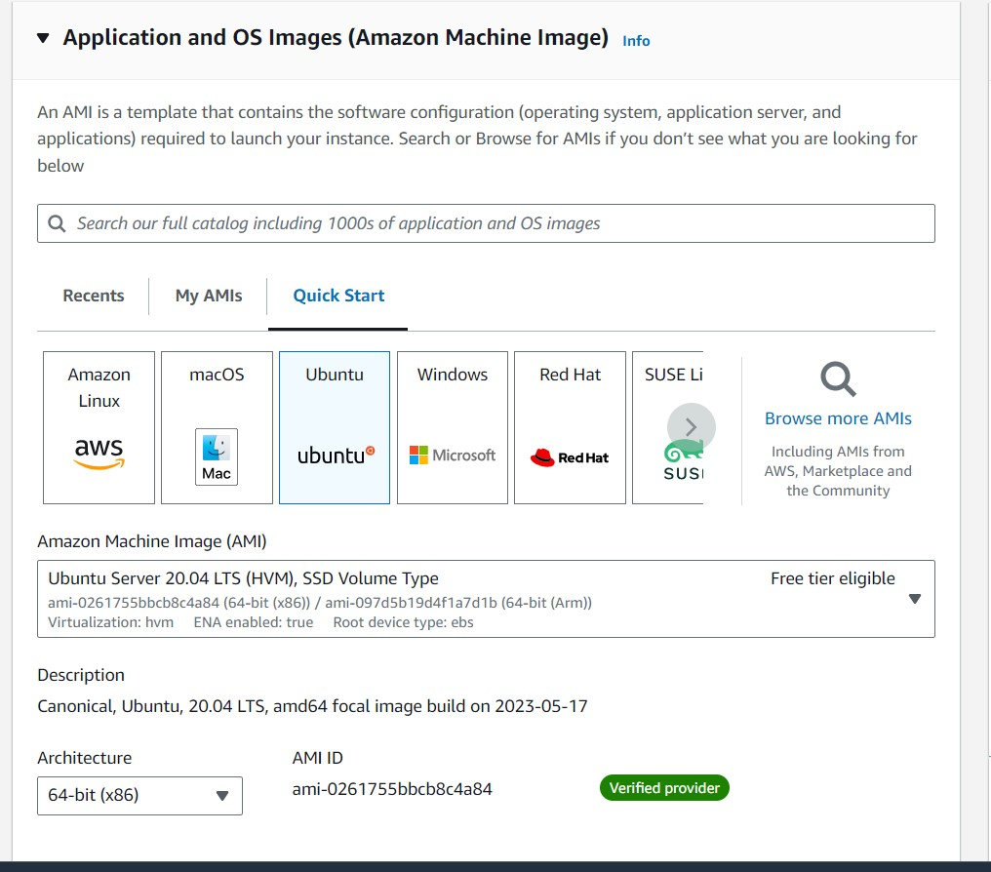

**Figure 4**

Key pair

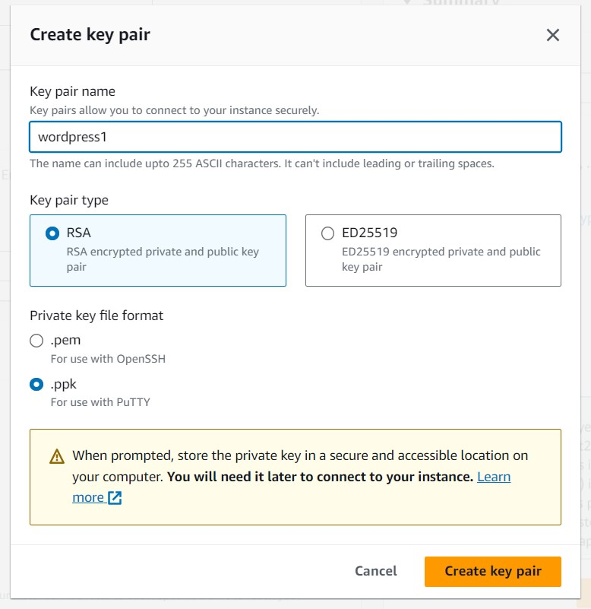

**Figure 5**

Configuring network

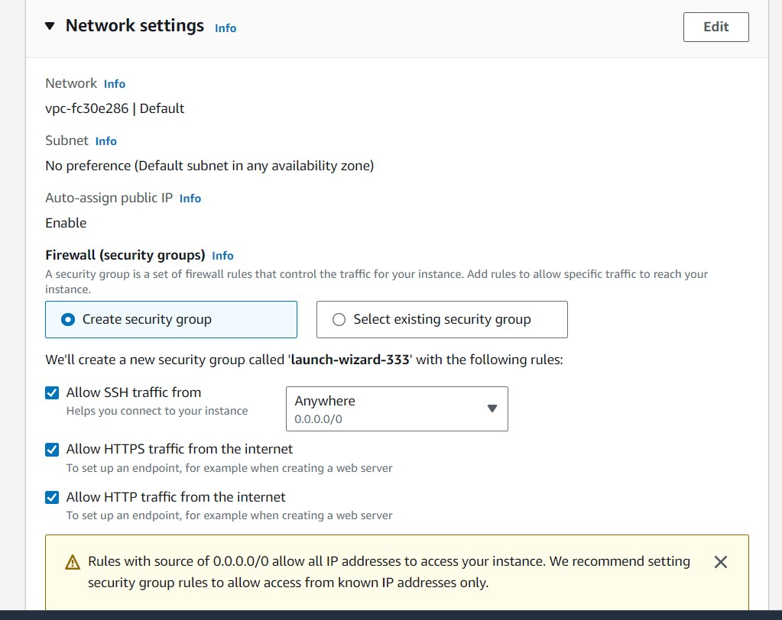

**Figure 6**

Configuring security groups

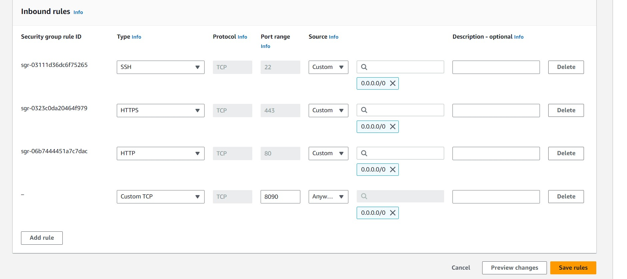

### 3.4.3. CyberPanel Management:

Leveraged CyberPanel for server management, including domain setup, email configuration, and DNS record management. Maintained server security through regular updates, patches, and security best practices. Managed server resources efficiently to accommodate website traffic and growth.

**Figure 7**

Connected to SSH client through AWS CLI

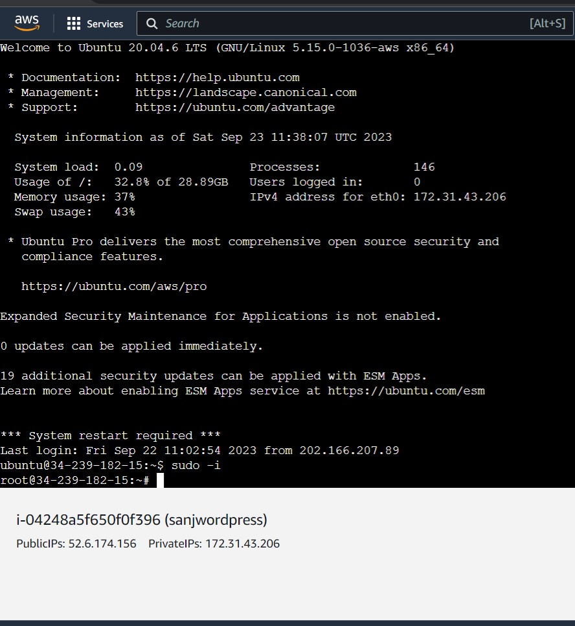

**Figure 8**

Logging in to Cyberpanel through instance IP

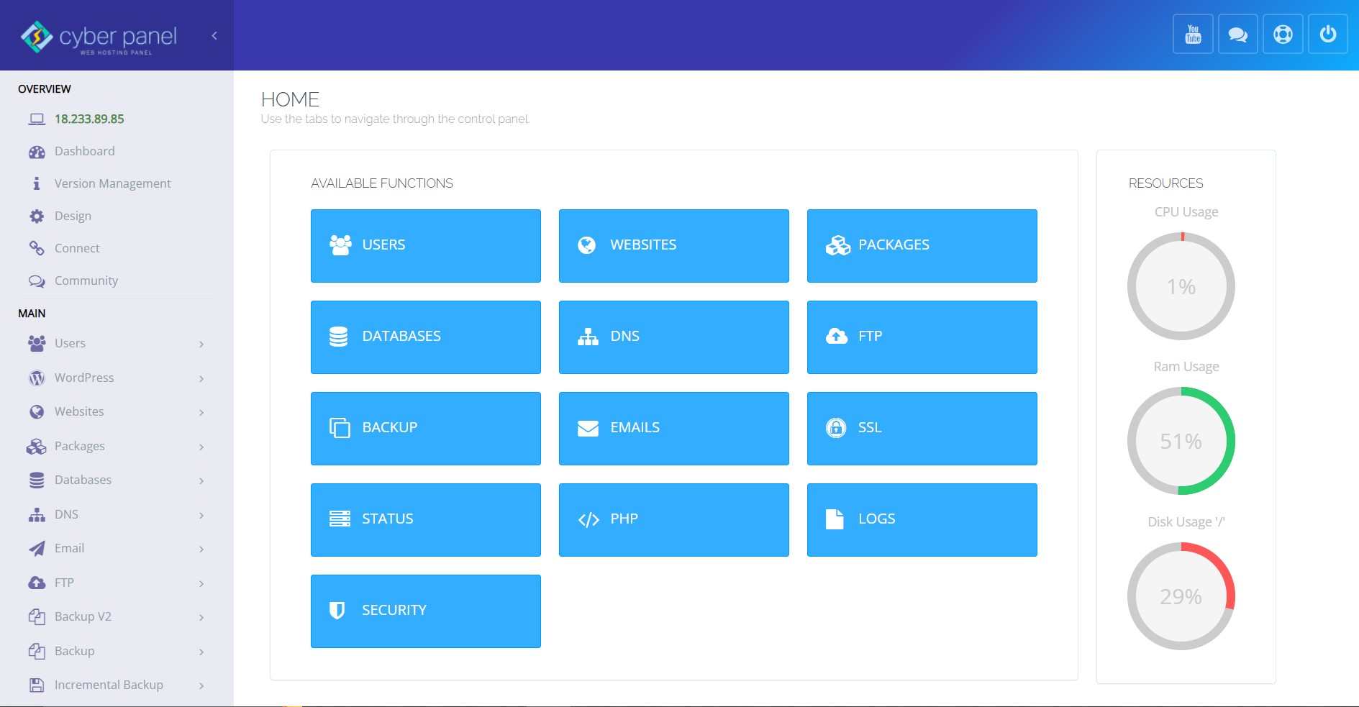

**Figure 9**

Cyberpanel Configuration

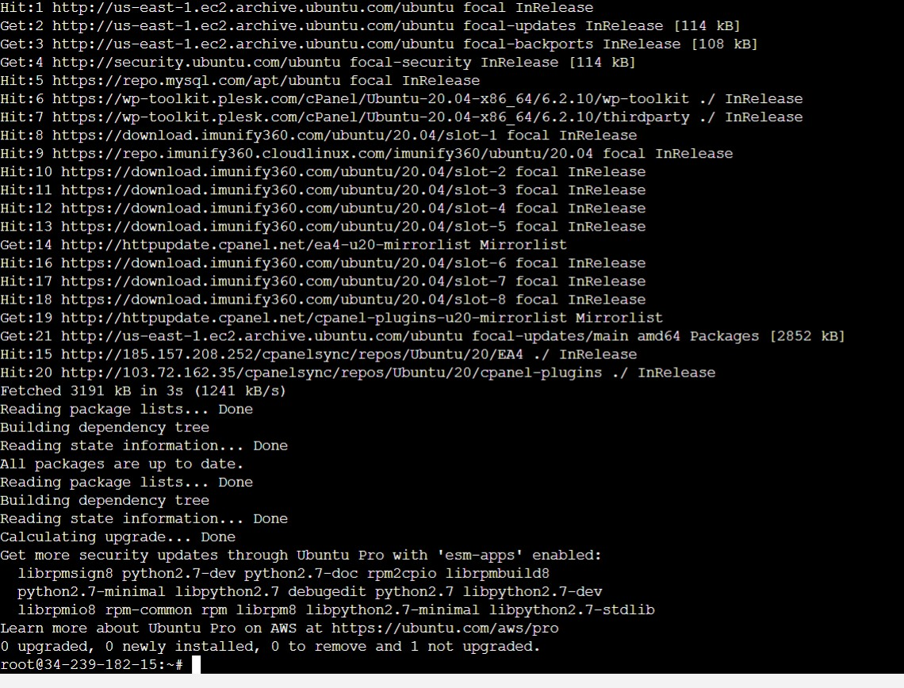

**Figure 10**

Installing wordpress on Cyberpanel

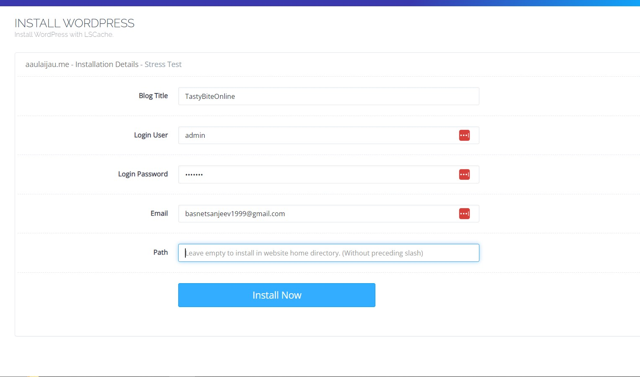

### 3.4.4. Nagios Monitoring:

Deployed Nagios, a robust monitoring solution, to continuously assess the health and performance of the AWS EC2 instance. Established alerting and notification mechanisms to promptly respond to critical events and performance anomalies. Monitored various server metrics, including CPU usage, memory utilization, and network traffic.

**Figure 11**

Nagios Installation

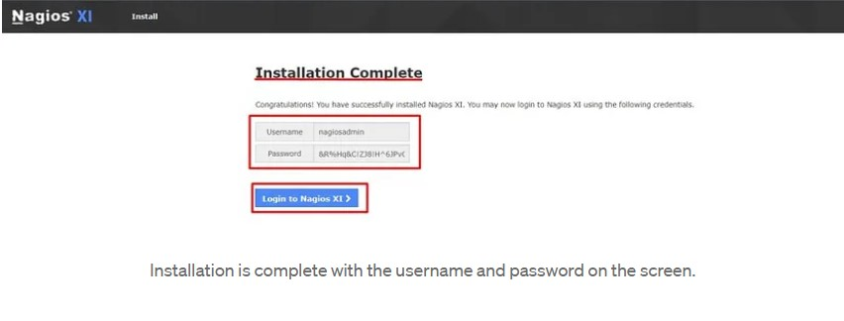

**Figure 12**

Monitoring current status of the website through Nagios

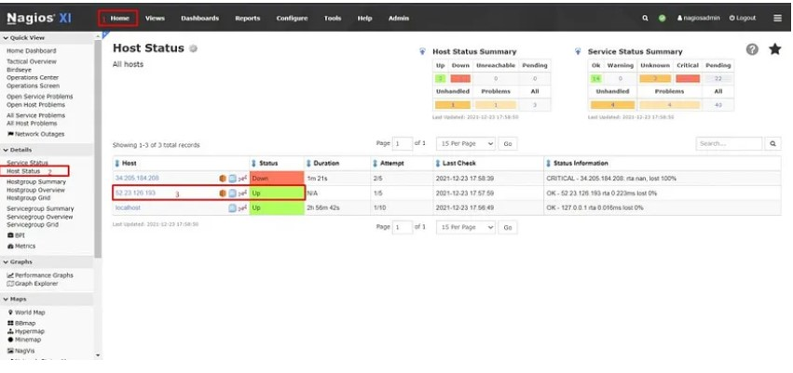

**Figure 13**

Monitoring EC2 instance

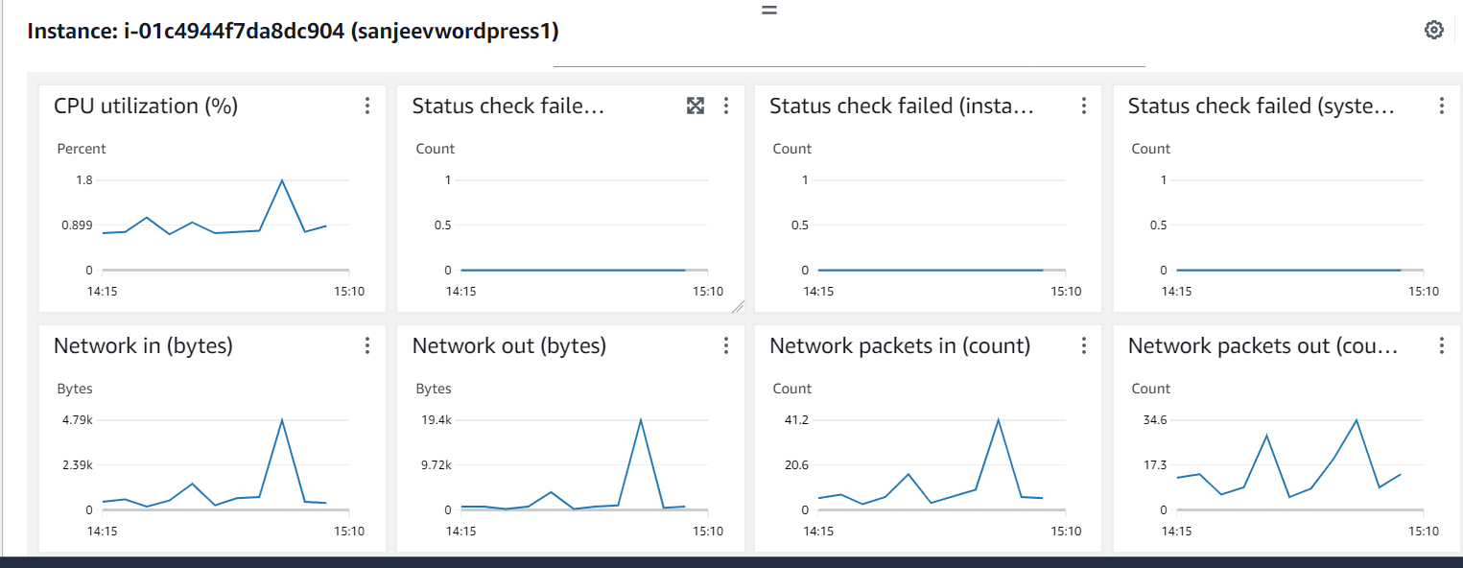

### 3.4.5. Testing and Quality Assurance:

Conducted rigorous testing of the website's functionality to ensure a seamless and error-free user experience. Identified and addressed any issues or bugs encountered during the migration, optimization, and testing phases.

**Figure 14**

Website migrated on AWS and logged in using Domain name and Ip address

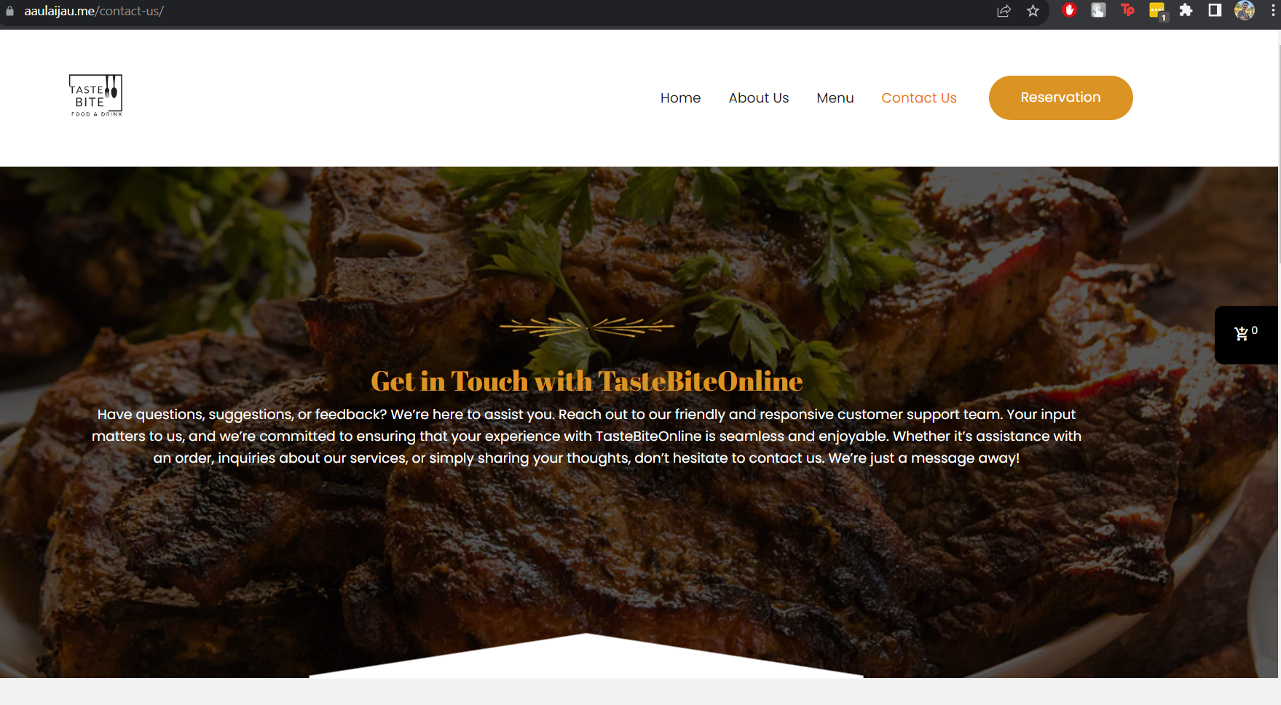

**Figure 15**

Billing details

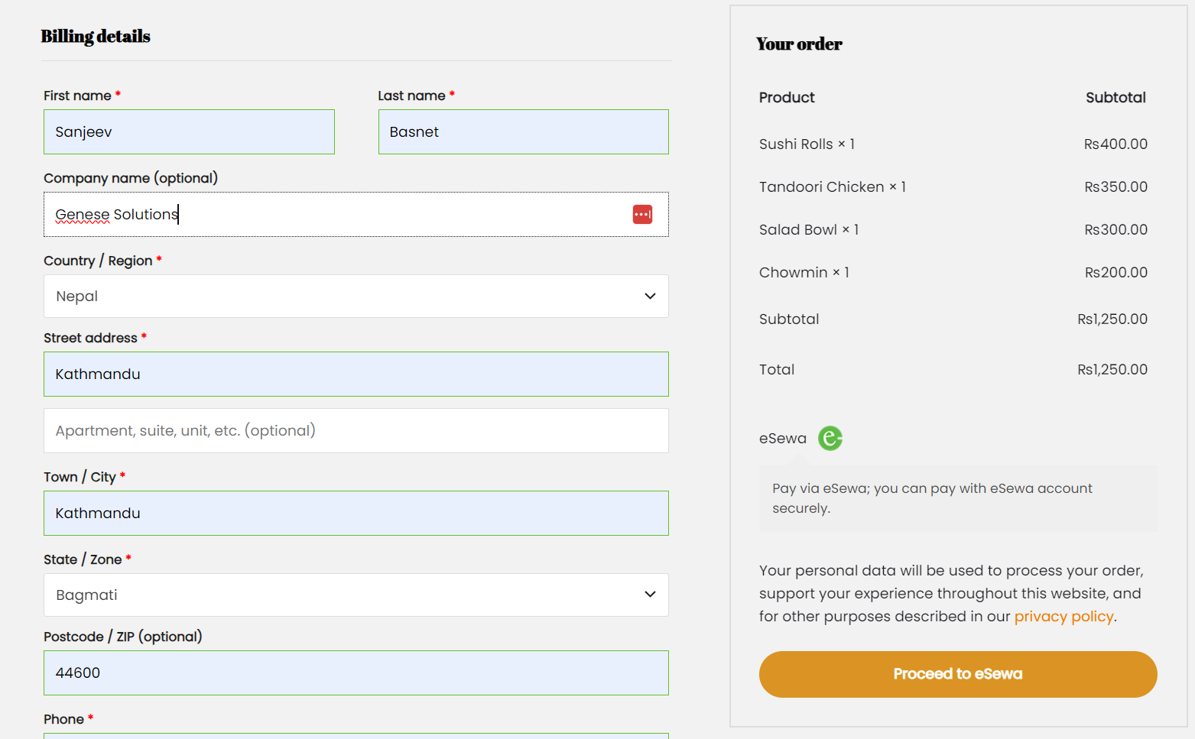

### 3.4.6. Finalization and Evaluation:

Conducted a comprehensive evaluation of the final state of the website, comparing its performance to predefined benchmarks and project goals. Gathered feedback to assess the effectiveness of the migration, optimization, and monitoring efforts.

# CHAPTER 4: CONCLUSION AND LEARNING OUTCOMES

## 4.1. Conclusion

The internship experience at Genese Solutions in the role of a Cloud Intern has proven to be an enriching and insightful journey. It has offered valuable insights into the cloud computing industry and exposed the author to the realities of a professional work environment. The knowledge and skills acquired during the author's academic pursuits proved to be exceptionally beneficial during their tenure as a Cloud Intern.

The author expresses deep gratitude for the opportunity to work within an organization of Genese Solutions' caliber, known for its strong reputation and high industry standards. The internship experience there was a priceless learning opportunity. The environment, characterized by supportiveness and dynamism, and underscored by a commitment to ongoing learning, facilitated a comprehensive understanding of cloud technologies, infrastructure as code, virtualization, and DevOps practices. Furthermore, the internship provided a platform for refining interpersonal skills and effective collaboration within a professional team.

This internship has not only bolstered the author's technical proficiency but has also led to the identification of strengths and areas in need of improvement. The author is enthusiastic about applying the knowledge and technical expertise gained during this internship to future endeavors. There is a firm commitment to addressing weak areas and maintaining a dedication to continuous improvement within the field of cloud computing.

## 4.2. Learning Outcomes

The internship experience as a Cloud Intern has provided a range of valuable learning outcomes:

### 4.2.1. Professional Level

* Gained hands-on experience in a real-world cloud computing environment.
* Enhanced communication skills, including effective team coordination.
* Developed a professional working behavior and attitude suitable for the industry.

### 4.2.2. Technical Level

* Acquired a solid understanding of cloud computing concepts and strategies.
* Gained expertise in cloud infrastructure management and deployment.
* Gained proficiency in the use of Infrastructure as Code (IAC) tools.
* Gained experience in configuring and optimizing cloud-based services and resources.
* Developed skills in designing, implementing, and managing cloud solutions.
* Acquired knowledge of DevOps practices for cloud infrastructure.
* Familiarity with cloud security best practices and compliance.
* Gained experience in troubleshooting and resolving cloud infrastructure issues.

# REFERENCES

*Amazon Web Services*. (2021). AWS: Amazon Web Services. https://aws.amazon.com/

Armbrust, M., Fox, A., Griffith, R., Joseph, A. D., Katz, R., Konwinski, A., ... & Zaharia, M. (2010). *A view of cloud computing. Communications of the ACM*, 53(4), 50-58.

Balachandar, V. (2017). *Securing cloud resources using AWS Identity and Access*

Brock, A., Butcher, A., & Chan, J. (2017). *AWS CloudFormation: User Guide. Amazon Web Services.*

*Genese Solution Limited*. (n.d.). Genese Solution. Retrieved September 24, 2023, from https://www.genesesolution.com/

Hassan, Q. (2018). *A review on cloud computing. Journal of Computer Science*, 14(1), 33-42.

Management (IAM). ProQuest Dissertations Publishing.

Mell, P., & Grance, T. (2011). *The NIST definition of cloud computing* (NIST Special Publication 800-145). National Institute of Standards and Technology.

Microsoft. (n.d.). *Cloud Computing Services | Microsoft Azure*. Azure.microsoft.com. https://azure.microsoft.com/en-us

*What Is an Internship? – Career Center - UMBC*. (n.d.). Career Center - UMBC. Retrieved June 25, 2023, from https://careers.umbc.edu/employers/internships/what-is-an-internship/

# APPENDICES

This section includes the signed and stamped weekly log reports prepared during the internship period.